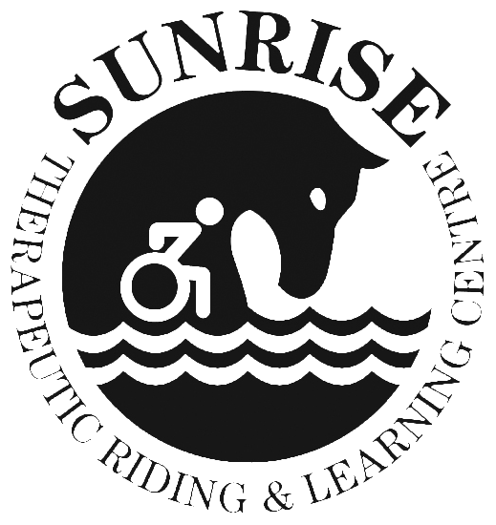
CLIENT NAME __________________________________________

6920 Concession 1, Puslinch, ON N0B 2J0 • 519-837-0558 • Fax 519-837-1233

www.sunrise-therapeutic.ca • office@sunrise-therapeutic.ca

Sunrise Policy R-10

DEGREE OF BODILY CONTACT WHEN WORKING WITH CLIENTS

Due to the nature of the work at Sunrise it is understood that instructors and trained volunteers will need to assist the majority of riders when mounting or riding a horse.

It may be necessary to lift a rider onto the horse, to correct posture by placing hands at the front or back of the trunk, or to correct leg and hand positions.

It is understood that this is part of the therapy/recreation sessions to which parents and riders have consented.

During riding sessions it may be necessary to quickly physically remove a rider from the group, due to behavioural or other concerns, and that this is done for the well-being of all concerned. This may involve two staff members lifting a rider.

Any bodily contact provided by the trained staff or personal care workers is in the interest of providing a safe and fun environment for the children, and will be undertaken with the utmost discretion.

Many of the children with special needs who attend Sunrise like to give hugs – this will be monitored by the staff so that other riders will not be placed in an embarrassing situation and behaviour will be modified as deemed necessary by staff.

“I have read, understood and agree to the terms of the policy”.

__________________________________ _____________________________________
Witness Signature of Individual

__________________________________ ______________________________________
Witness Signature of Parent/Guardian
if participant is under 18 years of age

__________________________________ _______________________________________
Date Date
____________________________________________________________________________________________________________

PHOTO RELEASE

For valuable consideration given and which is hereby acknowledged, the undersigned hereby grant to Sunrise Therapeutic Riding & Learning Centre permission to take, or have taken, still and moving photographs and films, including television pictures of our son/daughter/ward. Furthermore, the undersigned consents and authorizes Sunrise Therapeutic Riding & Learning Centre, and its advertising agencies, news media and any other persons interested in Sunrise Therapeutic Riding & Learning Centre and its work, to use and reproduce the photographs, films and pictures to circulate and publicize the same by all means, including and without limiting the generality of the foregoing, newspapers, television media, brochures, pamphlets, instructional materials, books and clinical material.

With regard to the foregoing material, no inducements or promises have been made to us/me to secure our/my signature(s) to this release other than the intention of Sunrise Therapeutic Riding & Learning Centre to use or be used such as photographs, films and pictures for the primary purpose of promoting and aiding the Sunrise Therapeutic Riding & Learning Centre and its work.

Dated this ____________________ day of __________________ , 20 _____

______________________________ ______________________________
(Witness) (Signature of Individual)
______________________________ ______________________________
(Witness) (Signature of Parent/Guardian)

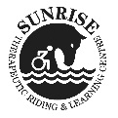

6920 Concession 1, Puslinch, Ontario N0B 2J0 • 519-837-0558 • Fax 519-837-1233

www.sunrise-therapeutic.ca • office@sunrise-therapeutic.ca

WAIVER, ASSUMPTION OF RISK & RELEASE OF LIABLITY

Initial below after reading and understanding each item:

____ I agree as a precondition to my participation or the participation of my child in horse riding/driving/vaulting/grooming/ equine facilitated wellness and any other activity involving horses (hereafter called “Equine Activities”) organized by Sunrise Therapeutic Riding & Learning Centre (Sunrise) and conducted by Sunrise or their employees or volunteers and in further consideration of being permitted to do so to be strictly bound by the terms of this Waiver, Assumption of Risk and Release of Liability.

____ I enter into this agreement with Sunrise recognizing that “Equine Activities” is inherently a risky undertaking, due to the sometimes unpredictable behaviour of horses, regardless of their continual training and past reliable performance.

____ I understand that all Sunrise instructors are certified through the Canadian Therapeutic Riding Association (CanTRA) or other equivalent national associations or there may be a student instructor, working under the direction of a fully certified instructor.

____ I understand that all participants must wear an ASTM (American Society for Testing and Materials) approved riding helmet.

____ I am aware that there are inherent dangers, hazards and risks (collectively “Risks”) associated with “Equine Activities” and injuries may result from these “Risks”. I am aware that the “Risks” of “Equine Activities” mean those dangerous conditions which are an integral part of “Equine Activities”, including but not limited to:

- The propensity of any equine to behave in ways that may result in injury, harm or death to persons on or around them and to potentially collide with, bite or kick other animals, people or objects.
- The unpredictability of an equine’s reaction to such things as sounds, sudden movement, tremors, vibrations, unfamiliar objects, persons or other animals and hazards such as subsurface objects.
- The potential for other participants to behave in a negligent manner that may contribute to injury to themselves or others, including failing to act within their abilities to maintain control over an equine.

____ I agree that this Waiver, Assumption of Risk and Release of Liability and all terms contained herein are governed exclusively and in all respects by the laws of the province or territory of Canada in which the “Equine Activities” are provided by Sunrise. I hereby irrevocably submit to the exclusive jurisdiction of the courts of that province or territory of Canada and I agree that no other court can exercise jurisdiction over the terms and claims referred to herein. Any litigation to enforce this waiver will be instituted in the province or territory of Canada in which the “Equine Activities” are provided by Sunrise.

____ I have read this entire Waiver, Assumption of Risk and Release of Liability document. I understand it is a promise to release Sunrise, its Directors, Officers, employees, volunteers and agents and the owners of the land upon which Sunrise operates from, all claims wheresover or howsoever arising now or in future. I have made a free and deliberate choice to sign this Waiver, Assumption of Risk and Release of Liability as a condition to allow me or my child to engage in “Equine Activities” organized by Sunrise Therapeutic Riding & Learning Centre (Sunrise).

________________________________ _________________________________ ________________

Print first and last name of client Signature of client or parent/guardian Date

